**SPORTS CLUB MEMBERSHIP**

**MODULE 1 (GUI)**

using System;

using System.Collections.Generic;

using System.ComponentModel;

using System.Data;

using System.Drawing;

using System.Linq;

using System.Text;

using System.Windows.Forms;

namespace Sports_Club_Membership

{

public partial class Home1 : Form

{

public Home1()

{

InitializeComponent();

}

private void label1_Click(object sender, EventArgs e)

{

}

private void button1_Click(object sender, EventArgs e)

{

this.Hide();

About2 f2 = new About2();

f2.Show();

}

private void button3_Click(object sender, EventArgs e)

{

this.Hide();

Manager_Login4 f4 = new Manager_Login4();

f4.Show();

}

private void button2_Click(object sender, EventArgs e)

{

this.Hide();

Registration3 f3 = new Registration3();

f3.Show();

}

private void pictureBox3_Click(object sender, EventArgs e)

{

}

private void pictureBox1_Click(object sender, EventArgs e)

{

}

private void Home1_Load(object sender, EventArgs e)

{

}

}

}

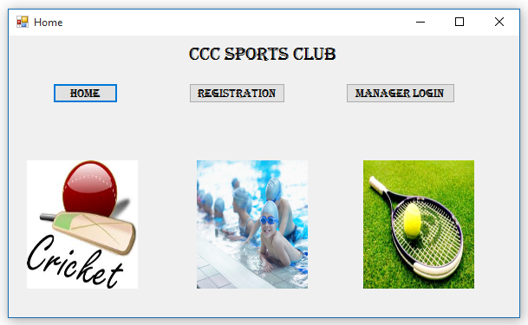

**MODULE 2 (ABOUT)**

using System;

using System.Collections.Generic;

using System.ComponentModel;

using System.Data;

using System.Drawing;

using System.Linq;

using System.Text;

using System.Windows.Forms;

namespace Sports_Club_Membership

{

public partial class About2 : Form

{

public About2()

{

InitializeComponent();

}

private void pictureBox2_Click(object sender, EventArgs e)

{

}

private void label1_Click(object sender, EventArgs e)

{

}

private void pictureBox1_Click(object sender, EventArgs e)

{

}

private void button1_Click(object sender, EventArgs e)

{

this.Hide();

Home1 f1 = new Home1();

f1.Show();

}

private void About2_Load(object sender, EventArgs e)

{

}

}

}

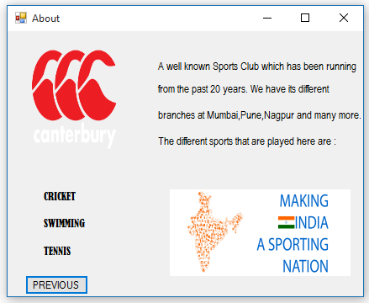

**MODULE 3 (REGISTRATION)**

using System;

using System.Collections.Generic;

using System.ComponentModel;

using System.Data.SqlClient;

using System.Drawing;

using System.Linq;

using System.Text;

using System.Windows.Forms;

namespace Sports_Club_Membership

{

public partial class Registration3 : Form

{

public Registration3()

{

InitializeComponent();

}

private void button1_Click(object sender, EventArgs e)

{

try

{

SqlConnection con = new SqlConnection(@"Data Source=.\SQLEXPRESS;Initial Catalog=SCM;Integrated Security=True");

string abc = "Insert into member_info (member_id,name,mob_no,home_phone,address,dob) values(@member_id,@name,@mob_no,@home_phone,@address,@dob)";

SqlCommand cmd = new SqlCommand(abc, con);

string pqr = "Insert into cricket (member_id) values(@member_id)";

SqlCommand cmd1 = new SqlCommand(pqr, con);

string xyz = "Insert into swimming (member_id) values(@member_id)";

SqlCommand cmd2 = new SqlCommand(xyz, con);

string stu = "Insert into tennis (member_id) values(@member_id)";

SqlCommand cmd3 = new SqlCommand(stu, con);

con.Open();

cmd.Parameters.AddWithValue("@member_id", maskedTextBox2.Text);

cmd.Parameters.AddWithValue("@name", textBox1.Text);

cmd.Parameters.AddWithValue("@mob_no", textBox2.Text);

cmd.Parameters.AddWithValue("@home_phone", textBox3.Text);

cmd.Parameters.AddWithValue("@address", textBox4.Text);

cmd.Parameters.AddWithValue("@dob", maskedTextBox1.Text);

cmd.ExecuteNonQuery();

cmd.Parameters.Clear();

if (checkBox1.Checked == true)

{

cmd1.Parameters.AddWithValue("@member_id", maskedTextBox2.Text);

cmd1.ExecuteNonQuery();

cmd1.Parameters.Clear();

}

if (checkBox2.Checked == true)

{

cmd2.Parameters.AddWithValue("@member_id", maskedTextBox2.Text);

cmd2.ExecuteNonQuery();

cmd2.Parameters.Clear();

}

if (checkBox3.Checked == true)

{

cmd3.Parameters.AddWithValue("@member_id", maskedTextBox2.Text);

cmd3.ExecuteNonQuery();

cmd3.Parameters.Clear();

}

con.Close();

this.Hide();

MessageBox.Show("Successfully Registered!!!");

}

catch

{

MessageBox.Show("Check either for blank entries or Member_id already used.Please enter another id.");

}

}

private void checkBox1_CheckedChanged(object sender, EventArgs e)

{

}

private void checkBox2_CheckedChanged(object sender, EventArgs e)

{

}

private void checkBox3_CheckedChanged(object sender, EventArgs e)

{

}

private void Form3_Load(object sender, EventArgs e)

{

}

}

}

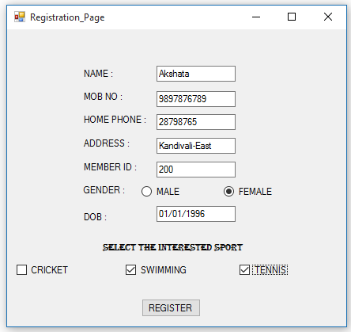

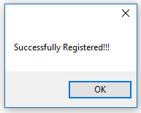

**MODULE 4 (MANAGER LOGIN)**

using System;

using System.Collections.Generic;

using System.ComponentModel;

using System.Data;

using System.Drawing;

using System.Linq;

using System.Text;

using System.Windows.Forms;

namespace Sports_Club_Membership

{

public partial class Manager_Login4 : Form

{

public Manager_Login4()

{

InitializeComponent();

}

private void button1_Click(object sender, EventArgs e)

{

if (textBox1.Text == "manager" && textBox2.Text == "manager")

{

this.Hide();

Access5 f5 = new Access5();

f5.Show();

}

else MessageBox.Show("Check Credentials");

}

private void textBox1_TextChanged(object sender, EventArgs e)

{

}

private void textBox2_TextChanged(object sender, EventArgs e)

{

}

private void Manager_Login4_Load(object sender, EventArgs e)

{

}

}

}

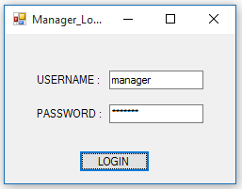

**MODULE 5 (ACCESS/UPDATE DATA)**

using System;

using System.Collections.Generic;

using System.ComponentModel;

using System.Data.SqlClient;

using System.Drawing;

using System.Linq;

using System.Text;

using System.Windows.Forms;

namespace Sports_Club_Membership

{

public partial class Access5 : Form

{

public Access5()

{

InitializeComponent();

}

private void button1_Click(object sender, EventArgs e)

{

this.Hide();

View_Details6 f6 = new View_Details6();

f6.Show();

}

private void button2_Click(object sender, EventArgs e)

{

this.Hide();

Delete_Record7 f7 = new Delete_Record7();

f7.Show();

}

private void textBox1_TextChanged(object sender, EventArgs e)

{

}

private void button3_Click(object sender, EventArgs e)

{

this.Hide();

Update_Data8 f8 = new Update_Data8();

f8.Show();

}

private void Access5_Load(object sender, EventArgs e)

{

}

}

}

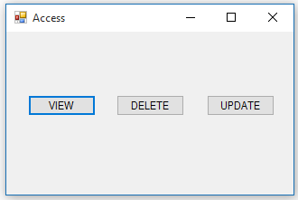

**MODULE 6 (VIEW)**

using System;

using System.Collections.Generic;

using System.ComponentModel;

using System.Data.SqlClient;

using System.Drawing;

using System.Linq;

using System.Text;

using System.Windows.Forms;

namespace Sports_Club_Membership

{

public partial class View_Details6 : Form

{

public View_Details6()

{

InitializeComponent();

}

private void label4_Click(object sender, EventArgs e)

{

}

private void label5_Click(object sender, EventArgs e)

{

}

private void button1_Click(object sender, EventArgs e)

{

this.Hide();

Access5 f5 = new Access5();

f5.Show();

}

private void textBox1_TextChanged(object sender, EventArgs e)

{

}

private void button2_Click(object sender, EventArgs e)

{

string conString = @"Data Source=.\SQLEXPRESS;Initial Catalog=SCM;Integrated Security=True";

SqlConnection con = new SqlConnection(conString);

string abc = textBox1.Text;

string selectSql = "select * from member_info WHERE [member_id]= '" + abc + "'";

SqlCommand com = new SqlCommand(selectSql, con);

try

{

con.Open();

using (SqlDataReader read = com.ExecuteReader())

{

while (read.Read())

{

textBox2.Text = (read["name"].ToString());

textBox3.Text = (read["mob_no"].ToString());

textBox4.Text = (read["home_phone"].ToString());

textBox5.Text = (read["address"].ToString());

textBox6.Text = (read["dob"].ToString());

}

}

}

catch

{

MessageBox.Show("Id does not exist.");

}

}

private void View_Details6_Load(object sender, EventArgs e)

{

}

}

}

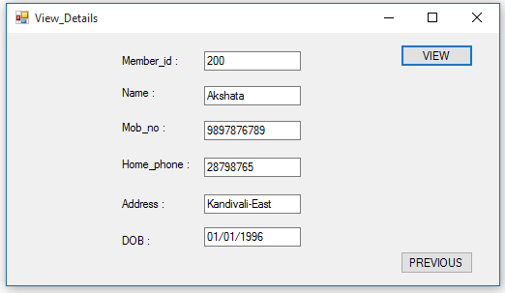

**MODULE 7 (UPDATE)**

using System;

using System.Collections.Generic;

using System.ComponentModel;

using System.Data.SqlClient;

using System.Drawing;

using System.Linq;

using System.Text;

using System.Windows.Forms;

namespace Sports_Club_Membership

{

public partial class Update_Data8 : Form

{

public Update_Data8()

{

InitializeComponent();

}

private void textBox1_TextChanged(object sender, EventArgs e)

{

}

private void button1_Click(object sender, EventArgs e)

{

try

{

SqlConnection con = new SqlConnection(@"Data Source=.\SQLEXPRESS;Initial Catalog=SCM;Integrated Security=True");

string abc = "UPDATE member_info SET [mob_no]=@mob_no WHERE [member_id]=@member_id";

SqlCommand cmd = new SqlCommand(abc, con);

string pqr = "UPDATE member_info SET [home_phone]=@home_phone WHERE [member_id]=@member_id";

SqlCommand cmd1 = new SqlCommand(pqr, con);

string xyz = "UPDATE member_info SET [address]=@address WHERE [member_id]=@member_id";

SqlCommand cmd2 = new SqlCommand(xyz, con);

con.Open();

if (checkBox1.Checked == true)

{

cmd.Parameters.AddWithValue("@mob_no", textBox2.Text);

cmd.Parameters.AddWithValue("@member_id", textBox1.Text);

cmd.ExecuteNonQuery();

cmd.Parameters.Clear();

}

if (checkBox2.Checked == true)

{

cmd1.Parameters.AddWithValue("@home_phone", textBox2.Text);

cmd1.Parameters.AddWithValue("@member_id", textBox1.Text);

cmd1.ExecuteNonQuery();

cmd1.Parameters.Clear();

}

if (checkBox3.Checked == true)

{

cmd2.Parameters.AddWithValue("@address", textBox2.Text);

cmd2.Parameters.AddWithValue("@member_id", textBox1.Text);

cmd2.ExecuteNonQuery();

cmd2.Parameters.Clear();

}

con.Close();

this.Hide();

MessageBox.Show("Successfully Updated!!");

}

catch

{

MessageBox.Show("Check Details");

}

}

}

}

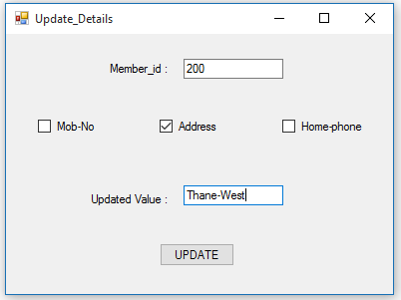

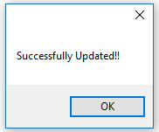

**MODULE 8 (DELETE)**

using System;

using System.Collections.Generic;

using System.ComponentModel;

using System.Data.SqlClient;

using System.Drawing;

using System.Linq;

using System.Text;

using System.Windows.Forms;

namespace Sports_Club_Membership

{

public partial class Delete_Record7 : Form

{

public Delete_Record7()

{

InitializeComponent();

}

private void button1_Click(object sender, EventArgs e)

{

try

{

SqlConnection con = new SqlConnection(@"Data Source=.\SQLEXPRESS;Initial Catalog=SCM;Integrated Security=True");

string abc = "DELETE FROM member_info WHERE [member_id]=@member_id";

SqlCommand cmd = new SqlCommand(abc, con);

con.Open();

cmd.Parameters.AddWithValue("@member_id", textBox1.Text);

cmd.ExecuteNonQuery();

cmd.Parameters.Clear();

con.Close();

this.Hide();

MessageBox.Show("Record has been deleted Successfully!!!");

}

catch

{

MessageBox.Show("Check Details");

}

}

private void textBox1_TextChanged(object sender, EventArgs e)

{

}

private void Delete_Record7_Load(object sender, EventArgs e)

{

}

}

}

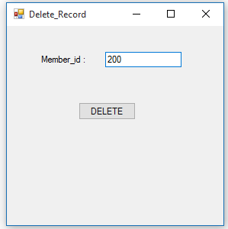

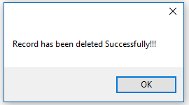

**DATABASE**

1) member_info

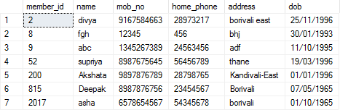

2) cricket

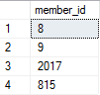

3) swimming

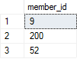

4) tennis

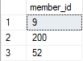

Updated Table

